**Alien fish threat to ecosystem**

June 2, 2023 @ 12:01am

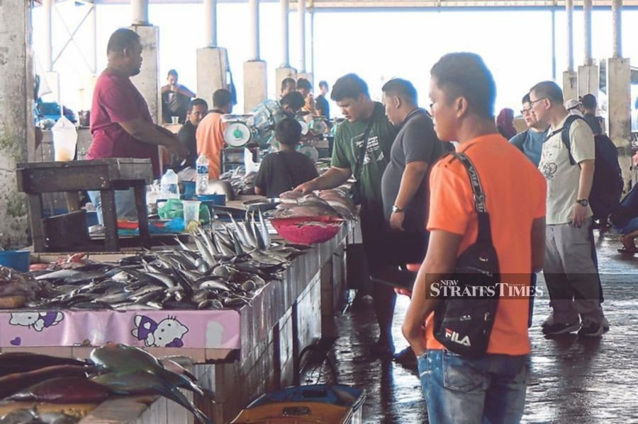We can ensure a healthy and sustainable supply of fish by giving priority to the use of native fish species in aquaculture. -NSTP/MOHD ADAM ARININ

**LETTERS:** Malaysia, like other nations, is facing many issues as a result of a decrease in fish catch, including an increase in costs and a deterioration in the quality of fish.

This is exacerbated by the intrusion of foreign fishing vessels, as well as unregulated fishing by local fishing vessels.

These challenges have implications for the food security and economic stability of the country.

Furthermore, the fall in the capture fisheries industry impacts fishing villages.

To address these challenges, alternative industries that supplement or even replace the capture fisheries industry have become increasingly important, like aquaculture, which involves the farming of fish and other aquatic organisms in confined environments, such as ponds and tanks.

There is growing recognition of aquaculture's potential to provide fish protein while also contributing to the economy.

To this end, various initiatives have been implemented.

For example, the Department of Fisheries (DoF) promotes the development of aquaculture, including the provision of technical assistance and training to farmers, the establishment of research and development, and the introduction of policies and regulations to support the sector.

The aquaculture sector in Malaysia is home to nearly 20,000 entrepreneurs.

This sector involves farming fish and other aquatic organisms in freshwater and brackish water.

Among the challenges faced by aquaculture operators is to maintain healthy and high-quality fish in the market.

To achieve this, some aquaculture operators resort to breeding alien fish species, which have proven to be lucrative.

But some of these alien fish species are known to be invasive, which will outcompete native or local species.

The aquaculture sector has introduced invasive alien fish species for livestock purposes, which have been assimilated into the water systems for an extended period of time.

African catfish and black tilapia have proliferated. People are becoming more aware about red-tailed catfish in aquatic habitats.

These alien fish are predators and will consume smaller indigenous fish, which can lead to a decline in local fish population and species.

The invasive alien fish may also harbour pathogens that are associated with the spread of new diseases, which can bring epidemics and mortalities to local species.

To mitigate these problems, aquaculture operators should prioritise the use of indigenous fish species in farming operations to maintain the balance of the ecosystem, promote biodiversity and ensure a sustainable supply of fish to the market.

It is important for aquaculture operators to be knowledgeable about the regulations established by the DoF and to seek its guidance.

Aquaculture operators should possess a deep understanding of the breeding of alien fish species and select an appropriate aquaculture livestock system to minimise the impact on fauna diversity.

Also, regular fish population monitoring and surveillance will help identify and address the presence of invasive species in water systems.

More studies are needed to find new local fish species and to boost the value of the fish in local aquaculture.

Invasive alien fish species have a significant impact on the ecosystem of nearby waters, and there is a lack of quality data on these effects.

We can ensure a healthy and sustainable supply of fish by giving priority to the use of native fish species, while putting in place measures to prevent the dispersion of invasive species in the aquatic ecosystem.

**DR NADIRAH MUSA**

**Associate professor**

**Aquatic Ecophysiology**

**Faculty of Fisheries and Food Science**

**Universiti Malaysia Terengganu**