**For some Malaysians, the forbidden fugu is a delicacy**

By [**JUNAID IBRAHIM**](https://www.thestar.com.my/authors?q=JUNAID+IBRAHIM)

* [**NATION**](https://www.thestar.com.my/news/nation/)
* Thursday, 30 Mar 2023

PETALING JAYA: Numbness in the face and mouth as well as difficulties in breathing are among the effects of consuming deadly toxins from puffer fish. Until today, there is no anti-toxin that could treat poisoning caused by puffer fish, experts say.

[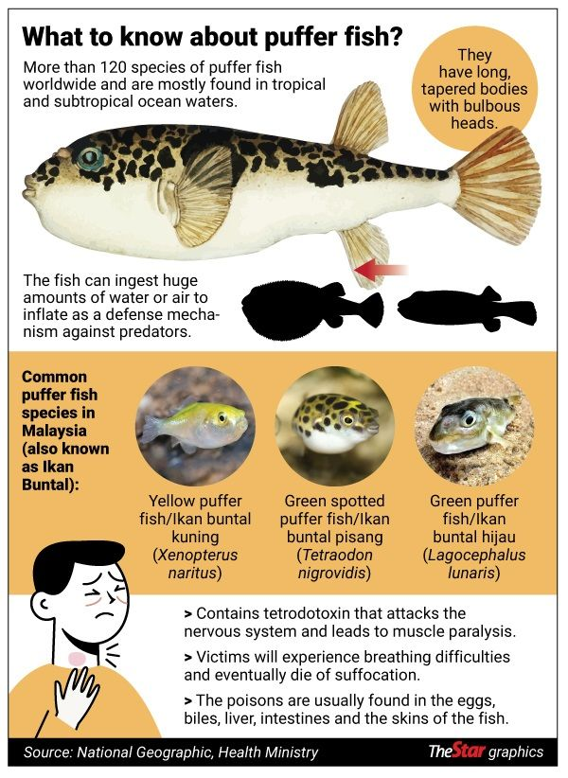](https://cdn.thestar.com.my/Content/Images/puffer_fish_info_30032023.jpg)

Despite that, the fish – which is locally known as “ikan buntal” – is still a delicacy among select groups in the country.

According to the Fisheries Department, a total of 1,337 tonnes of puffer fish landings were recorded in 2020.

“Consumers who bought filleted puffer fish online must also be aware of the species, as most puffer fishes varieties are poisonous,” the department said in a statement yesterday.

“Under the Food Act 1983, sellers who are found to be selling food that is harmful to humans could be fined or jailed,” it added.

Meanwhile, department director-general Datuk Adnan Hussain said that the public should avoid consuming unknown species of puffer fish.

Adnan also advised handlers of puffer fishes to be skillful in preparing the fish.

In Japan, where the fish is known as “fugu”, puffer fish handlers must be trained and certified by the government.

Fugu is usually served raw after removing the poisonous parts of the fish.

Relating his experience during a trip to Japan, ecommerce manager Evan Wong, 33, said he thought it would be an interesting and once-in-a-lifetime experience.

“I was at a market there and saw the dish on sale. After circling around the market several times, I decided to try it.

“After the first three bites, my face went numb which scared me.

“Finishing the fish also left me feeling numb for about five minutes before things returned to normal,” he said, adding that the experience also left him with slight shortness of breath.

In Sarawak, there was even a festival dedicated to the fish called “Pesta Ikan Buntal” held in Betong.

The villagers there would seek puffer fish for its tasty flesh, cooked in curry or spicy tamarind sauce, grilled or fried.

Meanwhile in Sabah – especially among the Bajau and Suluk ethnicities – there is a dish known locally as “sagol” or “sinagol”, which commonly consists of puffer fish meat and liver cooked in spices and tumeric.

A cook in a village in Semporna, Sabah, only known as Norisa, said she would ensure that only specific non-poisonous puffer fish was selected for the dish.

“We ensure that we use thorny puffer fish which is usually non-poisonous,” she said.

Universiti Malaysia Terengganu Vice Chancellor Prof Datuk Dr Mazlan Abd Ghaffar backed this up by saying that not all species of puffer fish are poisonous.

The most common species in Malaysian waters, he said, is Lagocephalus lunaris (green puffer fish), which is noted for its bright yellow tails.

“Most poisonous species contain a kind of neurotoxin known as tetrodotoxins, found in the muscles and internal organs of the puffer fish, as well as the skin.

“However, puffer fish species with spiny skin are widely sold in Sabah and the Philippines markets were said to be non-poisonous,” the marine scientist specialising in Fish, Fisheries and Marine Environment told The Star.

Academy of Sciences Malaysia fellow Prof Mustafa Ali Mohd explained that tetrodotoxin is commonly found in the liver, ovaries, skin and muscles of the puffer fish.

The toxin acts as a sodium blocker that inhibits minerals mobility through the cell membrane, which then leads to muscle paralysis.

“The poisoned victim may be conscious but will experience difficulty in breathing and eventually may die due to suffocation or asphyxia.

“The victim may feel tingling, numbness or paresthesia, especially in the mouth and arms,” the Mahsa University professor in medicine said.

Prof Mustafa said the victim might be able to survive the poisoning if early treatment was given.