PM: Landslide issue in Terengganu being looked into

NATION

Sunday, 16 Apr 2023

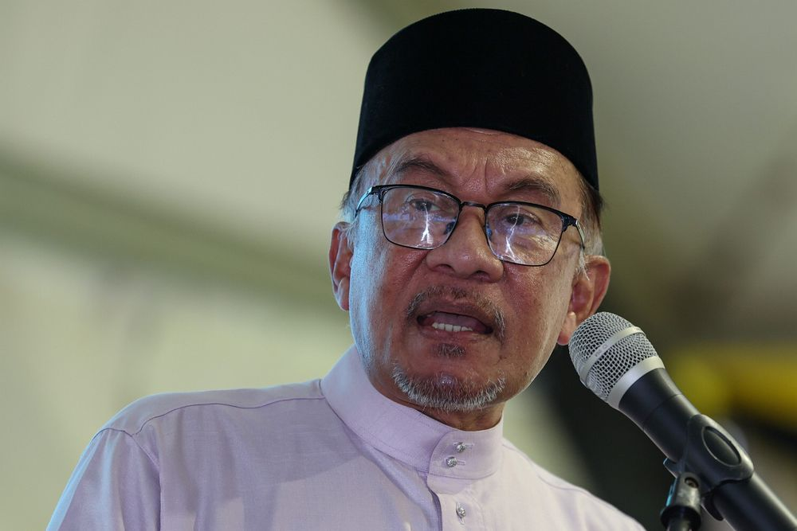

KUALA NERUS: The landslide issues around Tasik Kenyir will be given immediate attention to ensure the safety of the people of Terengganu, says Datuk Seri Anwar Ibrahim (pic).

The Prime Minister said although Terengganu is an Opposition-led state, the federal and state governments must face and solve the people’s problems together.

“I have discussed with the Chief Secretary to the Government (Tan Sri Mohd Zuki Ali), if it is to protect the safety of the lake area and Terengganu because of water overflow and the damage that may occur, then surely we will act fast.

“Although the Mentri Besar (Datuk Seri Dr Ahmad Samsuri Mokhtar) is from another party, that is not an issue.

“If the problem affects the people, then we must face it together,” he said at the Prime Minister’s Malaysia Madani breaking of fast event with the people at Dewan Sultan Mizan, Universiti Malaysia Terengganu (UMT) here yesterday, Bernama reported.

The event, which was also attended by Ahmad Samsuri and Mohd Zuki, attracted about 1,500 students and people from around Kuala Nerus.

Anwar also emphasised his stance on improving cooperation with state governments, including Opposition states, for the benefit of the people.

For example, he said, the Federal Government would not sideline Opposition states under the revised Budget 2023 announced in February, with additional allocations for the states, including Terengganu, besides flood mitigation projects that also involve Terengganu and Kelantan.

The Prime Minister said he is open to criticisms and censure from state governments, including Opposition states, against any of his actions and decisions provided they do not have elements of personal attacks that divide the people.

“I will improve cooperation with the states. I hope that they, especially the Opposition at the federal level, can also give their cooperation,” he said.

At the event, he handed over a contribution of 100 UMT Rahmah Baskets to the poor in Kuala Nerus.

There was also a ceremony for the handing over of tithes by eight agencies comprising Maybank Bhd, Bank Rakyat, Etiqa Takaful Bhd, the Terengganu Islamic Religion and Malay Customs Council, RHB Bank, AmBank Group Bhd, Perumahan Kinrara Bhd and Takaful Malaysia Sdn Bhd, totalling RM815,211, to the UMT Students’ Zakat Fund.

Subscribe now to our Premium Plan for an ad-free and unlimited reading experience!